The Cornerstone Federation
Parent Governor Vacancy - July 2020
The Cornerstone Federation for The Bay CE School and Niton Primary School has always aimed for a partnership with parents, which undoubtedly brings great benefits to the children. We currently have a vacancy for a parent governor and are looking for someone to join our dedicated Governing Board.
Would you like to be a member of a dynamic and progressive Governing Board who challenge and support the school leaders and ensure the best possible education for the children in your community?
The Governing Board's main tasks are:
· to ensure that the school has a clear vision, ethos and strategic direction;
· to hold the headteacher to account for the educational performance of the school and its pupils;
· to oversee the financial performance of the school and make sure its money is well spent.
Parent governors are vital members of the team and play a pivotal role in ensuring the Governing Board is aware of the views of parents and the local community.
Training and support will be available to help the elected person to develop into the role. This will include in-house mentoring and support as well as access to external governor training.
If you feel you can help in this capacity please download an application form from our website or alternatively contact the school office. Applications will need to be completed and returned to the school by 12.00 noon on Friday 24th July 2020.
Please note that for the protection of children all governor appointments are subject to an identity and DBS check.
If there are more applications than vacancies, we will hold an election and you will be sent a voting paper in due course. You may return the ballot paper either via your child or by post.
Yours faithfully,
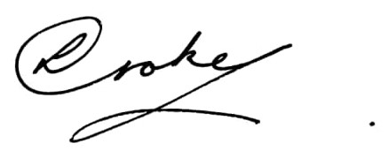
Lisa Croke
Chair of Governors

